- 8 QUEEN PROBLEM
Aim:
To solve the 8-Queen Problem using Backtracking in Python by placing eight queens on an 8 × 8 chessboard such that no two queens attack each other.
Objective:
- To understand the concept of the 8-Queen Problem.
- To implement the Backtracking algorithm.
- To place eight queens safely on the chessboard.
- To ensure that no two queens share the same row, column, or diagonal.
- To display the valid arrangement of queens.
Algorithm:
- Start the program.
- Create an empty 8 × 8 chessboard.
- Begin placing queens from the first column.
- Check whether the current position is safe.
- If safe, place the queen.
- Move to the next column and repeat the process.
- If no safe position is found, remove the previously placed queen (Backtracking).
- Continue until all 8 queens are placed.
- Display the chessboard.
- Stop the program.

Flow Chart:
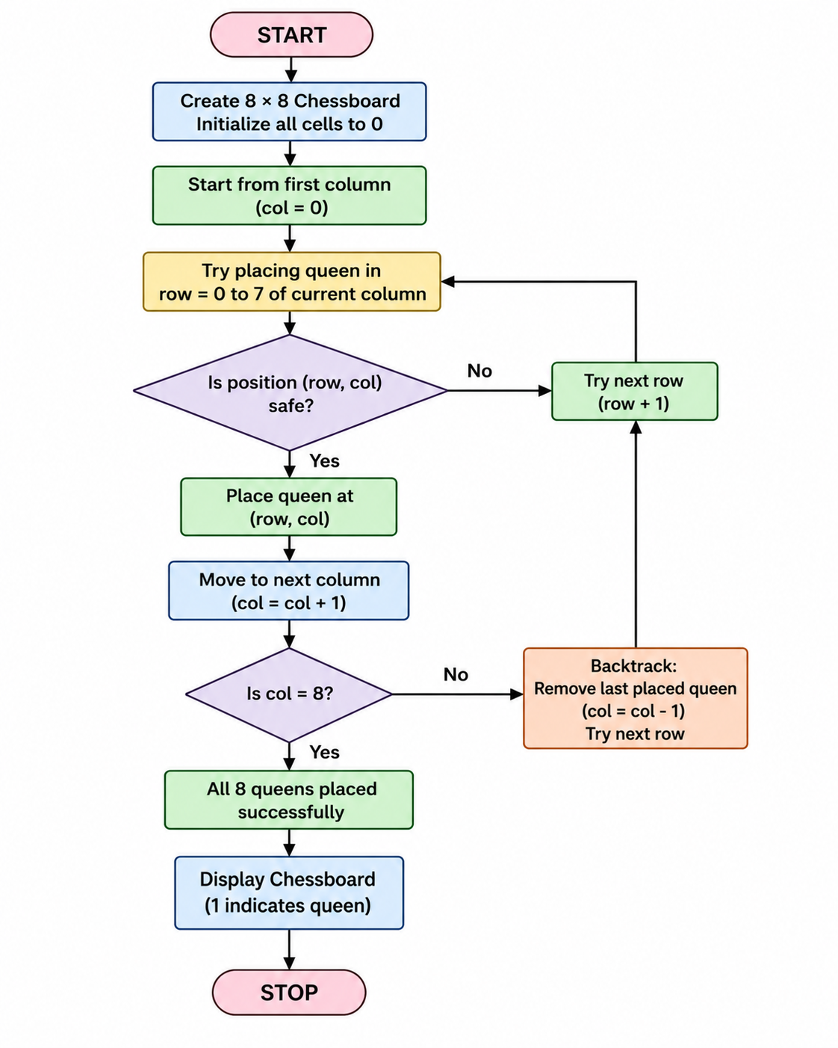

Code:
N = int(input("Enter the number of queens: "))

x = [-1] * N

def safe(r, c):
for i in range(c):
if x[i] == r or abs(x[i] - r) == abs(i - c):
return False
return True

def queen(c):
if c == N:
print("\nSolution:")
for i in range(N):
print(x[i], end=" ")
return True

for r in range(N):
if safe(r, c):
x[c] = r
if queen(c + 1):
return True
return False

if not queen(0):
print("No Solution")
Output:
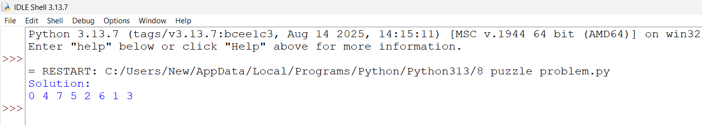
Result:
The 8-Queen Problem was successfully solved using the Backtracking algorithm in Python. The program placed eight queens on the chessboard such that no two queens attacked each other and displayed a valid solution.

